SOLID Design Principles in C#
The SOLID Design Principles in C# are the design principles that help us to solve most of the software design problems. These design principles provide us with multiple ways to move the tightly coupled code(higher interdependence system) between the software components which makes the software designs more understandable, flexible, and maintainable.

Why do we need SOLID Design Principles?
As a developer, we start developing applications using our experience and knowledge. But over time, the applications might arise bugs. We need to alter the application design for every change request or for a new feature request. After some time we might need to put a lot of effort, even for simple tasks, it might require the full working knowledge of the entire system. But we can’t blame change or new feature requests as they are part of the software development. We can’t stop them and refuse them either.
Advantages of SOLID Design Principles in C#
As a developer, while you are designing and developing any software applications, then you need to consider the following points.
Maintainability:
Nowadays maintaining the software is the biggest challenge for the Industry. Day by day the business grows for the organization and as the business grows you need to enhance the software with new changes. So you need to design the software in such a way that it should accept future changes with minimum effort and without any problem.
Testability:
Test-Driven Development (TDD) is one of the most important key aspects nowadays when you need to design and develop a large-scale application. We need to design the application in such a way that we should test each individual functionalities.
Flexibility and Extensibility:
Nowadays flexibility and extensibility both are very much required for enterprise applications. So we should design the application in such a way that it should be flexible so that it can be adapted to work in different ways and extensible so that we can add new features easily with minimum modifications.
Parallel Development:
The Parallel Development of an application is one of the most important key aspects. As we know it is not possible to have the entire development team will work on the same module at the same time. So we need to design the software in such a way that different teams can work on different modules.
Introduction to SOLID Design principles in C#
The SOLID Design principles are basically used to manage most of the software design problems that generally as a developer we face in our day-to-day programming. SOLID principles represent five design principles that basically used to make the software designs more understandable, flexible, and maintainable.
SOLID Acronym
- S stands for the Single Responsibility Principle which is also known as SRP.
- O stands for the Open-Closed Principle which is also known as OSP.
- L stands for the Liskov Substitution Principle which is also known as LSP.
- I stand for the Interface Segregation Principle which is also known as ISP.
- D stands for Dependency Inversion Principle which is also known as DIP.
What are the Advantages of using SOLID Design Principles in C#?
We will get the following advantages of using SOLID Design Principles in C#.
- Achieve the reduction in complexity of the code
- Increase readability, extensibility, and maintenance
- Reduce error and implement Reusability
- Achieve Better testability
- Reduce tight coupling
Single Responsibility Principle in C#
The Single Responsibility Principle in C# states that “Each software module or class should have only one reason to change“. In other words, we can say that each module or class should have only one responsibility to do.
So we need to design the software in such a way that everything in a class or module should be related to a single responsibility. That does not mean your class should contain only one method or property, you can have multiple members (methods or properties) as long as they are related to a single responsibility or functionality. So, with the help of SRP in C#, the classes become smaller and cleaner and thus easier to maintain.
How can we achieve the Single Responsibility Principle in C#?
Let us understand the need for the Single Responsibility Principle in C# with an example. Suppose we need to design an Invoice class. As we know an Invoice class basically used to calculate various amounts based on its data. The Invoice class does not know how to retrieve the data, or how to format the data for display, print, logging, or sending an email, etc.
If we write the database logic, business logic as well as display logic in a single class, then our class performing multiple responsibilities. Then it becomes very difficult to change one responsibility without breaking the other responsibilities. So, by mixing multiple responsibilities into a single class, we are getting the following disadvantage,
- Difficult to understand
- Difficult to test
- Chance of duplicating the logic of other parts of the application
Example: Without using Single Responsibility Principle in C#:
Please have a look at the following diagram that we want to implement in the following example.
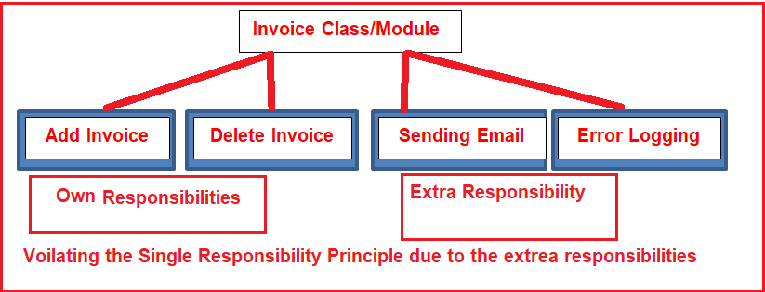
Please have a look at the following diagram.
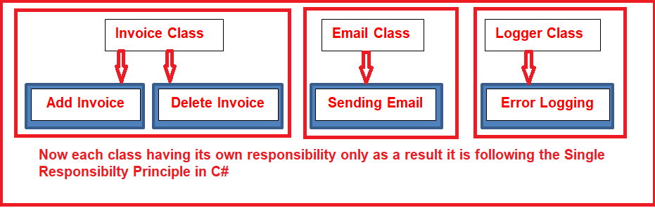
As you can see in the above diagram, now we are going to create three classes. In the invoice class, only the invoice-related functionalities are going to be implemented. The Logger class is going to be used only for logging purposes. Similarly, the Email class is going to handle Email activities. Now each class having only its own responsibilities, as a result, it follows the Single Responsibility Principle in C#.
EXAMPLE OF SINGLE RESPONSIBILITY PRINCIPAL
public interface IEmail
{
void Email1();

}

//public interface IError
//{
// string IError { get; set; }

//}

public interface IInvoice
{

void addinvoice();

// string addinvoice { get; set; }

}
public class invoice :IInvoice
{

public void addinvoice()
{
Console.WriteLine("my first invoice");
}

public void delinvoice()
{
Console.WriteLine("my first invoice deleted");
}

class Email : IEail
{
public void Email1()
{
Console.WriteLine("send fist mail");
}
}

//class Error :IError
//{
// public void error()
// {
// Console.WriteLine("my first error");
// }
//}
static void Main(string[] args)
{

invoice i = new ConsoleApplication3.invoice();
i.addinvoice();
i.delinvoice();
}
}

What is the Open-Closed Principle in C#?
The Open-Closed Principle states that “software entities such as modules, classes, functions, etc. should be open for extension, but closed for modification“.
Let us understand the above definition in simple words. Here we need to understand two things. The first thing is Open for extension and the second thing is Closed for modification. The Open for extension means we need to design the software modules/classes in such a way that the new responsibilities or functionalities should be added easily when new requirements come. On the other hand, Closed for modification means, we should not modify the class/module until we find some bugs.
The reason for this is, we have already developed a class/module and it has gone through the unit testing phase. So we should not have to change this as it affects the existing functionalities. In simple words, we can say that we should develop one module/class in such a way that it should allow its behavior to be extended without altering its source code.
Problems of Not following the Open-Closed Principle in C#:
If you are not following the Open-Closed Principle during the application development process, then you may end up your application development with the following problems
- If you allow a class or function to add new logic then as a developer you need to test the entire functionalities which include the old functionalities as well as new functionalities of the application.
- As a developer, it is also your responsibility to tell the QA (Quality Assurance) team about the changes in advance so that they can prepare themselves in advance for regression testing along with the new feature testing.
- If you are not following the Open-Closed Principle, then it also breaks the Single Responsibility Principle as the class or module is going to perform multiple responsibilities.
- If you are implementing all the functionalities in a single class, then the maintenance of the class becomes very difficult.
Let us understand the Open-Closed Principle in C# with one example.
Please have a look at the following diagram.
Real Life Example of Open Closed Principle

An electric adapter is a good example of this principle.



As you can see in the image:
- An adapter in the wall is always closed for modification, in other words we cannot change it once it is fitted or extended if we want more.
- But an adapter always provides a method of extension, so we can plug in an extension board of an adapter for more adaptation.
- So you plug in an extension board and extend an existing electric adapter fitted in wall.
Example of not following the principle in Application Development

A bank offers various types of the savings accounts (Salary Saving, Regular Saving and so on) that meet the needs of many types of customers. A bank has differing sets of rules and each savings account type has a different set of rules to calculate interest.

To calculate the interest of an account, developers have developed the following class with methods to calculate interest.
- Public class SavingAccount
- {
- //Other method and property and code
- Public decimal CalculateInterest(AccountType accountType)
- {
- If(AccountType==”Regular”)
- {
- //Calculate interest for regular saving account based on rules and
- // regulation of bank
- Interest = balance * 0.4;
- If(balance < 1000) interest -= balance * 0.2;
- If(balance < 50000) interest += amount * 0.4;
- }
- else if(AccountType==”Salary”)
- {
- //Calculate interest for saving account based on rules and regulation of
- //bank
- Interest = balance * 0.5;
- }

- }
- }
So in the preceding code the SavingAccount class's CalculateInterest method does a calcualtion based on the account type like Salary and Regular.

So the implementation is not following the Open Closed principle because if tomorrow the bank introduces a new SavingAccount type then there is a requirement to modify this method for adding a new case for the new account type. An example is if the bank introduces a “Child Savings Account type” requiring a new condition for calculating the interest for this account type. That means that the method is always open for modification.
How to Implement the Open Closed Principle

Inheritance is only one way to implement the Open Closed Principle. Because inheritance is only an Object Oriented Design (OOD) basic pillar that allows extension of functionality of an existing class.

To implement the Open Closed Principle one can use interface, an abstract class, abstract methods and virtual methods than inherit them when you want to extend functionality.

So the preceding problem of a Savings Account can be resolved as in the following.

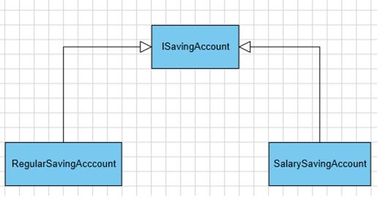
- Interface ISavingAccount
- {
- //Other method and property and code
- decimal CalculateInterest();
- }
- Public Class RegularSavingAccount : ISavingAccount
- {
- //Other method and property and code related to Regular Saving account
- Public decimal CalculateInterest()
- {
- //Calculate interest for regular saving account based on rules and
- // regulation of bank
- Interest = balance * 0.4;
- If(balance < 1000) interest -= balance * 0.2;
- If(balance < 50000) interest += amount * 0.4;
- }
- }

- Public Class SalarySavingAccount : ISavingAccount
- {
- //Other method and property and code related to Salary Saving account`
- Public decimal CalculateInterest()
- {
- //Calculate interest for saving account based on rules and regulation of
- //bank
- Interest = balance * 0.5;
- }
- }
- Public class childsavingaccount:IServiceaccount
- {
- Public decimal CalculateInterest()
- {
- }
In the preceding code two new classes are created, Regular Savings Account and SalarySavingAccount, that is inherited from IsavingAccount.

So if there is a new account added by the bank than there is no need to modify the logic of exiting classes, just extend the functionality by inheriting an interface.

Finally the preceding example implements the Open Closed Principle since there is no need to modify the existing implemented logic and it allows extension for adding new logic.

Implementation Guidelines for the Open-Closed Principle (OCP) in C#
- The easiest way to implement the Open-Closed Principle in C# is to add the new functionalities by creating new derived classes which should be inherited from the original base class.
- Another way is to allow the client to access the original class with an abstract interface.
- So, at any given point of time when there is a change in requirement or any new requirement comes then instead of touching the existing functionality, it’s always better and suggested to create new derived classes and leave the original class implementation as it is.

Liskov Substitution Principle in C#?
The Liskov Substitution Principle is a Substitutability principle in object-oriented programming Language. This principle states that, if S is a subtype of T, then objects of type T should be replaced with the objects of type S.
In simple words we can say that, when we have a base class and child class relationships i.e. inheritance relationships, then, if we can successfully replace the object/instance of a parent class with an object/instance of the child class, without affecting the behavior of the base class instance, then it is said to be in Liskov Substitution Principle. If you are not getting this point properly, don’t worry, we will see some real-time examples to understand this concept.
For example, a father is a teacher whereas his son is a doctor. So here, in this case, the son can’t simply replace his father even though both belong to the same family.
Without using the Liskov Substitution Principle in C#:
Let us first understand one example without using the Liskov Substitution Principle in C#. In the following example, first, we create the Apple class with the method GetColor. Then we create the Orange class which inherits the Apple class as well as overrides the GetColor method of the Apple class. The point is that an Orange cannot be replaced by an Apple, which results in printing the color of the apple as Orange as shown in the below example.
namespace SOLID_PRINCIPLES.LSP
{
class Program
{
static void Main(string[] args)
{
Apple apple = new Orange();
Console.WriteLine(apple.GetColor());
}
}
public class Apple
{
public virtual string GetColor()
{
return "Red";
}
}
public class Orange : Apple
{
public override string GetColor()
{
return "Orange";
}
}
}
As you can see in the above example, Apple is the base class and Orange is the child class i.e. there is a Parent-Child relationship. So, we can store the child class object in the Parent Reference variable i.e. Apple apple = new Orange(); and when we call the GetColor i.e. apple.GetColor(), then we are getting the color of the Orange not the color of Apple. That means once the child object is replaced i.e. Apple storing the Orange object, the behavior is also changed. This is against the LSP Principle. The Liskov Substitution Principle in C# states that even the child object is replaced with the parent, the behavior should not be changed. So, in this case, if we are getting the color of Apple instead of Orange, then it follows the Liskov Substitution Principle. That means there is some issue with our software design. Let us see how to overcome the design issue and makes the application follow Liskov Substitution Principle.
Example Using the Liskov Substitution Principle in C#
Let’s modify the previous example to follow the Liskov Substitution Principle. Here, first, we need a generic base class such as Fruit which is going to be the base class for both Apple and Orange. Now you can replace the Fruit class object with its subtypes either Apple and Orage and it will behave correctly. Now, you can see in the below code, we created the super Fruit class as an abstract class with the GetColor abstract method and then the Apple and Orange class inherited from the Fruit class and implement the GetColor method.

namespace SOLID_PRINCIPLES.LSP
{
class Program
{
static void Main(string[] args)
{
Fruit fruit = new Orange();
Console.WriteLine(fruit.GetColor());
fruit = new Apple();
Console.WriteLine(fruit.GetColor());
}
}
public abstract class Fruit
{
public abstract string GetColor();
}
public class Apple : Fruit
{
public override string GetColor()
{
return "Red";
}
}
public class Orange : Fruit
{
public override string GetColor()
{
return "Orange";
}
}
}

mespace SOLID_PRINCIPLES.LSP
{
class Program
{
static void Main(string[] args)
{

